Product Overview:
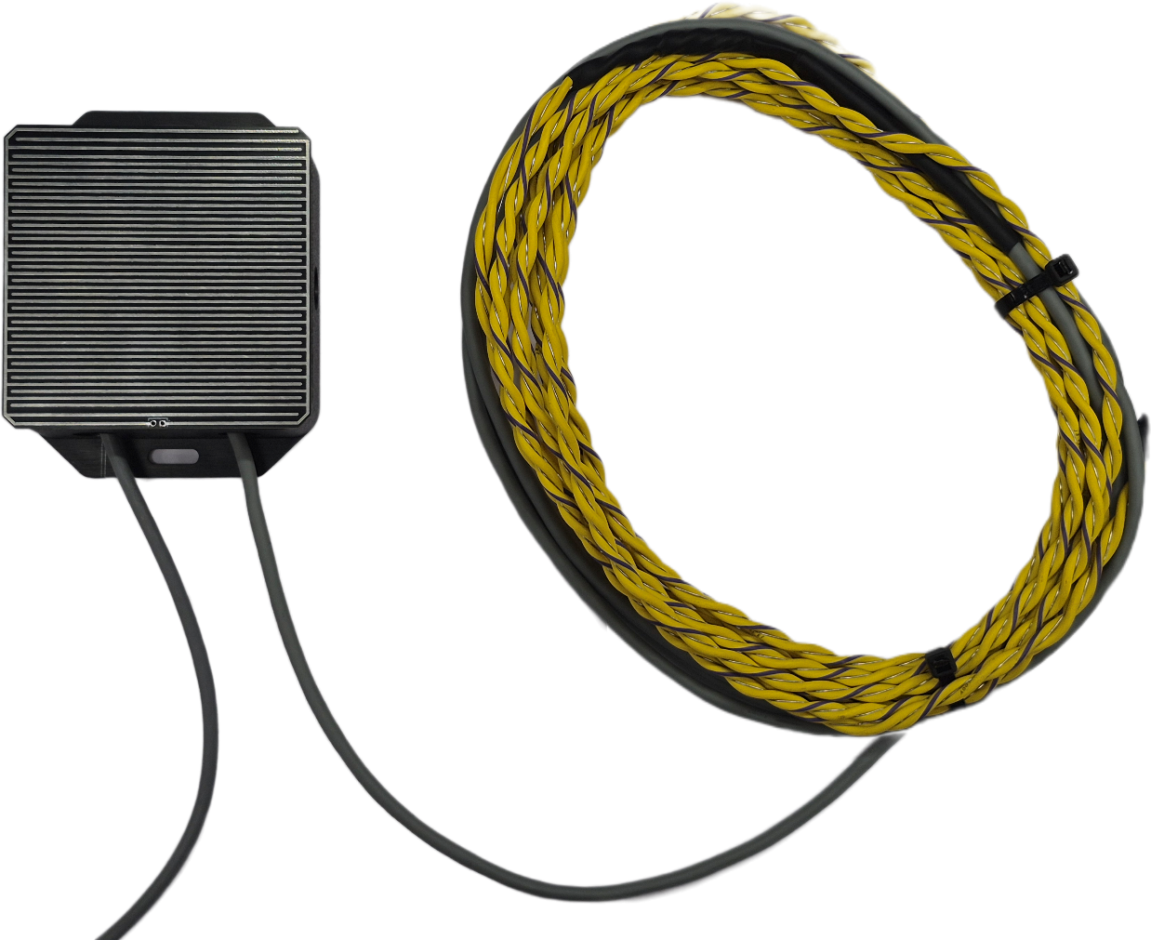
The WIN-SN-WLD-M-W is a highly reliable, dual-communication solution engineered for precise, multi-point water leakage detection. It is ideal for safeguarding critical infrastructure in sensitive environments such as server rooms, industrial facilities, data centers, and smart commercial buildings. The device ensures seamless integration into both localized and cloud-based IoT networks by offering simultaneous data transmission via a robust Modbus RS485 interface and wireless WiFi MQTT protocols. The module provides flexible deployment options tailored to specific safety and control needs, ensuring rapid and accurate detection of fluid ingress over long distances with high resistance to electrical interference..

One of the key advantages of the device is its highly versatile 3-channel detection architecture. Depending on the specific monitoring application, users can dynamically configure the module to support either three independent water leakage sensing cables, or a hybrid combination of two sensing cables alongside one integrated top-mounted conductive plate. To further streamline installation and commissioning, the device utilizes software-based "soft settings" for Modbus configuration, allowing technicians to easily assign network parameters without manually toggling physical dipswitches.
General Specification:
- Product dimension: 100*100*60 mm.
- Power supply DC: 12-60V DC @ 2A

- Certifications:

Configuration setting:
Communication Speed 9600 – 115200 (Software Configurable)
Slave ID 1-247 (Software Configurable)
Data Bits 8
Parity None
Stop bit 1
CRC Yes
Function code 0X02 (Read Discrete Inputs)
Function code Address 0,1,2.

MOSBUS Register Configuration

ID | Function  Description | Register  Description | Modbus Function Code | Protocol | Data  Type
1 | WLD1 | 40001 | 0X02 | RS485 | 16 Bit Unsigned int
2 | WLD2 | 40002 | 0X02 | RS485 | 16 Bit Unsigned int
3 | WLD3 | 40003 | 0X02 | RS485 | 16 Bit Unsigned int
4 | Display Baud Rate (Default:960) | 40011 | 0x03 | RS485 | 16 Bit Unsigned int
5 | Enter New Baud Rate | 40012 | 0x03 | RS485 | 16 Bit Unsigned int
6 | Display Slave ID (Default:1) | 40013 | 0x03 | RS485 | 16 Bit Unsigned int
7 | Enter New Slave ID | 40014 | 0x03 | RS485 | 16 Bit Unsigned int
8 | Display Parity  (Default: None-3, Odd-1, Even-2) | 40015 | 0x03 | RS485 | 16 Bit Unsigned int
9 | Enter New Parity | 40016 | 0x03 | RS485 | 16 Bit Unsigned int
10 | Display Stop Bit  (start-2/stop bit-1) | 40017 | 0x03 | RS485 | 16 Bit Unsigned int
11 | Enter New Stop Bit | 40018 | 0x03 | RS485 | 16 Bit Unsigned int
12 | Save Modbus Settings | 40019 | 0x03 | RS485 | 16 Bit Unsigned int
13 | Reset Modbus Settings | 40020 | 0x03 | RS485 | 16 Bit Unsigned int

MOSBUS Mbpoll Configuration
- Here is an example of receiving data on Mb poll software.
- Open Mb-poll software connect using configuration setting (Default baud rate is 9600 and slave id is 1.
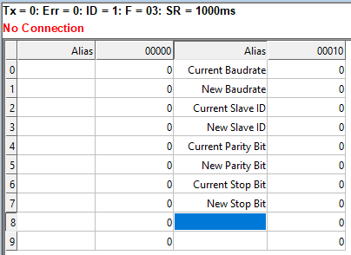
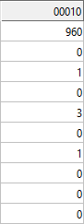
- After connecting you will get data as shown below

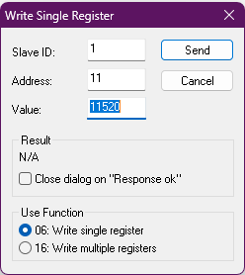
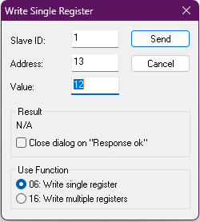
- As you can see in the image above, the resistor 40010 – 960 represents the present bund rate (9600) of the board and 40012 – 1 represents the present slave id of the board.

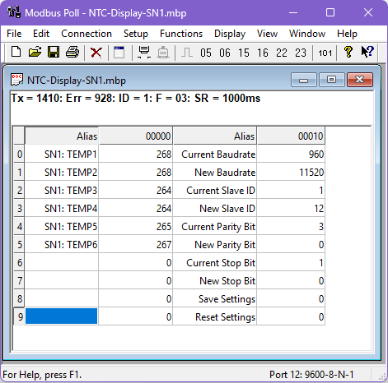
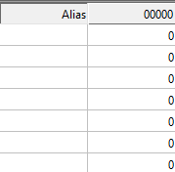
- To change the baud rate and slave id you must enter a value on the 40011 resistors for the baud rate and 40013 for the slave id as shown in the image below.

- After that, Press EN button of simply reboot the device.
- If you want to enter the baud rate 9600/19200/38400/57600/115200etc. Enter it like this 960/1920/5760/11520etc.

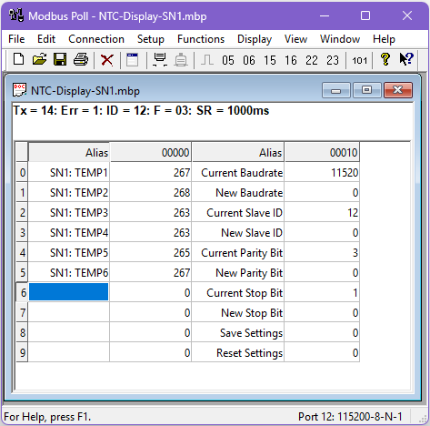

- Then you will get the present value of 11520 at 40011 baud rate(115200) and 12 at 40013 slave id.

- Network Parameter Recovery: In the event of lost communication parameters, factory default settings (9600 Baud, Slave ID 1) can be instantly restored by shorting the DS_RST jumper and pressing the EN button within the PCB.

Device Configuration Process
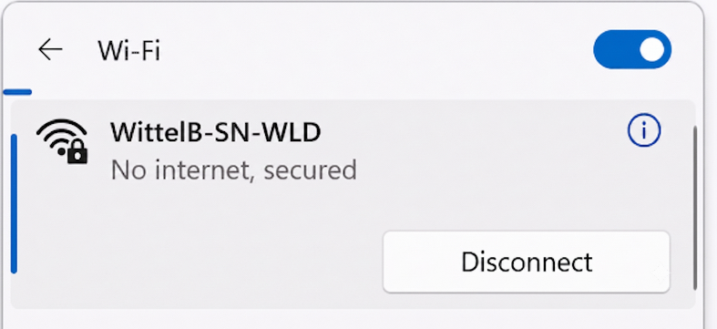
- Connect the Device
  - Connect 12v-1A DC adaptor to power the board
  - Connect the Wi-Fi SSID: WittelB-SN-WLD Pass:123456789
  - Enter the IP 192.168.4.1 in web browser
  - Refer image 1 for Wi-Fi WittelB-SN-WLD
Image: 1

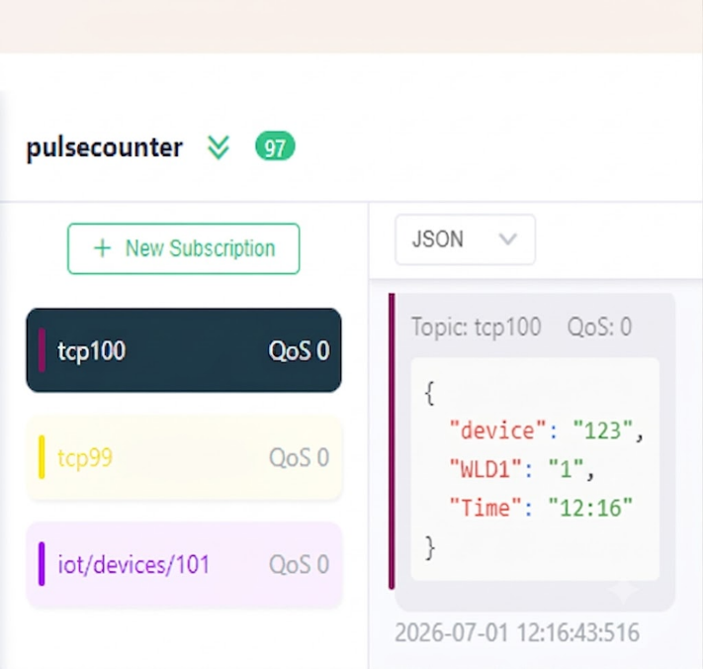
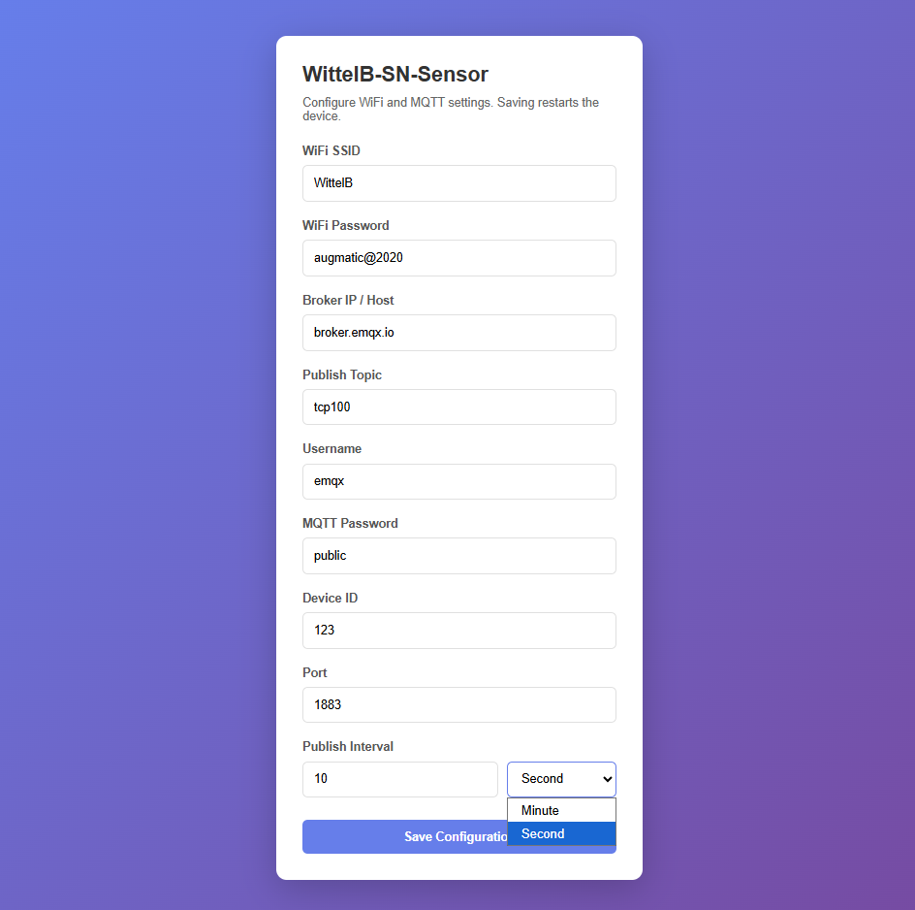
Image: 2 Image: 3

- Enter IP 192.168.4.1 in web browser then you will see the Web UI.
- Enter the local WiFi credentials as shown in above image2 so the device can connect to that WiFi network. Using this connection, it will send the sensor data to the cloud.
- Then enter the required MQTT Credentials and make sure the Credentials should be correct.
- As shown in Image 2, you can select the publish interval in either minutes or seconds. MQTT data will be published according to the selected interval.
- Enter the MQTT credentials to transmit the sensor data to the cloud.
- Image 3 shows the sensor data at cloud for the selected topic.

Hardware Overview & Interfaces

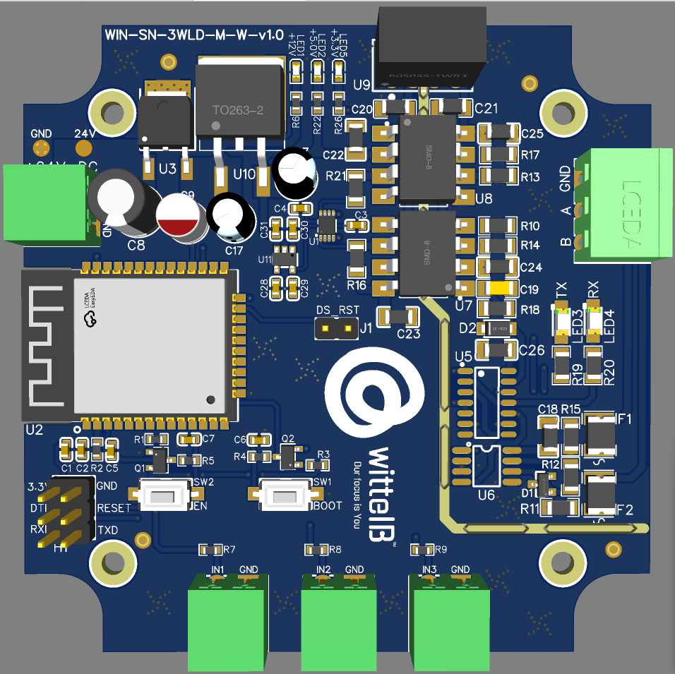
Modbus Reset Jumper
IN1 | IN2 | IN3
WLD INPUTS
POWER LED
MCU RESET
MODBUS PORT
Input Supply
+24V DC
POLLING LED

Contact Information
Augmatic Technologies Pvt. Ltd.,
Plot no 6, Shah Industrial Estate II,
Kotambi,
Vadodara – 391510.
Email – Sales@wittelb.com
Support: support@wittelb.raiseaticket.com / +91 94038 92805

